*MedTime* - Medication Adherence Improvement

*2Sofia Lee, 1Riad Touma, 3Isaac Rico, 3Scott Borges,*

*1Ali Kiapour and 2Chen-Hsiang Yu*

1Department of Biomedical Engineering, Wentworth Institute of Technology, Boston, MA

2Department of Computer Science and Networking, Wentworth Institute of Technology, Boston, MA

3Department of Computer Information Systems, Wentworth Institute of Technology, Boston, MA

***Abstract:*** According to the WHO report on medication adherence in 2003, approximately 50% of patients with chronic illness do not take medications as prescribed. This kind of poor medication can have a serious outcome, either patients or the cost in the medication process. The research question behind the theme is that how to improve medication adherence. In this paper, we propose to use a customized mobile application to embed different reminding mechanisms to mitigate the issue. *MedTime*, an Android Mobile Application, is designed to help the patients take medicines as prescribed. The current result shows that the designed system not only can provide an easy-to-use user interface for medicine taking behavior, but it also has a potential to help medical doctors to analyze the patients’ medication history.

***Keywords:*** Mobile app, Mobile prescription tracker, Pill tracker, Mobile health, Mobile app device

# **I. Introduction**

According to the World Health Organization (WHO) Adherence meeting in June 2001, the adherence is defined as “the extent to which a person’s behavior – taking medication, following a diet, and/or executing lifestyle changes, corresponds with agreed recommendations from a health can provider”. In 2003, the WHO report on medication adherence indicates that approximately 50% of patients with chronic illness do not take medications as prescribed [1]. The poor medication can have serious outcomes, either death for patients or the increased cost in the medication process.

The research question behind the theme is that how to improve medication adherence. In this paper, we propose to use a customized mobile application to embed different reminding mechanisms to mitigate the issue. *MedTime* is an Android Mobile Application that is designed for medication adherence improvement, i.e. help the patients take medicines as prescribed.

To address medication adherence issues, we conclude a few guidelines, including: a mobile app platform which gives reminders for all your meds and times; displays your notes, such as "take with food"; can handle very complicated dosing schedules; send your friends and family notifications if you want help staying on track if you miss a dose, track dozens of measurements such as blood pressure, weight, and glucose all in one place; see daily and monthly medication progress reports that you can send to a doctor or nurse ahead of an appointment; and the ability to select a sound for medication reminders and notifications. We used these guidelines and ordered them based on how important we believed they were to the project and by the ability of our coder. The three ones we focused on were:

1. a mobile app platform which gives reminders for all your meds, times and displays your notes such as "take with food"
2. See daily and monthly medication progress reports that you can send to a doctor or nurse ahead of an appointment
3. the ability to select a sound for medication reminders and notifications

We used these as a starting point in our research and tried to include as much of the other guidelines along the way when we develop and release the software system.

# **II. Related Work**

In the past, researchers spent time addressing medication adherence issue with mobile devices. According to Wu [2], “Almost all participants used the application at least once. More than half reported that they took their medications immediately when they received reminders.” Similarly, Hammonds et. al.’s study investigated medication adherence by using medication reminding via smartphone app. The result of the study indicates that “There was a strong trend suggesting that the use of a medication reminder app was beneficial for adherence to antidepressant medication regimens.” In addition, the study also concludes that “Use of a medication reminder may increase adherence to antidepressant medications in college students.” [4] This shows that even just a slight reminder daily for a college student that is dreading taking the medication or forgetting to take the medication will be reminded and will be saved possibly from any life-threatening situations. “Reminders sent via text messages have been shown to improve adherence in chronic diseases.” [5] This fact has been one of the leading driving forces behind creating these applications to remind patients to take their medication.

Medisafe is a current application used today for medication reminders. Our group modeled our application similarly to theirs because Medisafe is one of the top applications on the market today for medication adherence. [5] “Medisafe was ranked number 1 among the advanced medication reminder apps”. Medisafe was deemed to be the best because “it was found to be interesting, entertaining, highly interactive, and customizable and to have a high level of visual appeal.” Also, the application was recommended to others by most users. [5] A problem with a lot of mobile phone apps available is that a majority do not have everything that is desired from a user/patient, meaning they are somewhat not as effective as they can potentially be. Medisafe is one of the upper scale applications as it was ranked much higher than most apps in many different studies. There are thousands of different applications as well, which are not worth mentioning.

# **III. Proposed Idea & Research Hypothesis**

People today have issues with remembering to take their medication daily, especially elderly people, therefore our application is made to improve medication adherence for patients using the application. There are points in people lives where money is wasted, and their health is at risk due to forgetfulness of taking their medication and eating certain foods with certain medications. Also, we want to focus on the dosage of the medication so that we can specify exactly how much is required of a certain pill or of certain medication to take during that day, week or month.

To deal with the problem of forgetfulness, we design and develop an app to try and combat this issue. This application will be a virtual pill box that will send you notifications on when you need to take a pill, if you missed taking a pill, or you need to add or subtract a pill from your daily intake.

As everyone is at times forgetful about if they have or haven’t done something, we believe that this application could be for anyone. We think this app will be for men and women 60 and up. Anyone can benefit from this app but with memory loss being more prominent in the older generations we believe they will benefit the most.

We think this application will address the problem of forgetfulness in humans. One way to stay healthy or recover from a sickness is to stay on top of one’s medication. This app should at least alleviate some of the pressure of having to remember if one has taking his or her drugs.

# **IV. Design of the System**

A patient, when prescribed a medication by a doctor, will receive information about the medication, for example, dosage, days interval, and times it should be taken. However, humans forget. Therefore, this app is designed to solve low medication adherence rate, which is caused by not taking prescribed medications correctly.

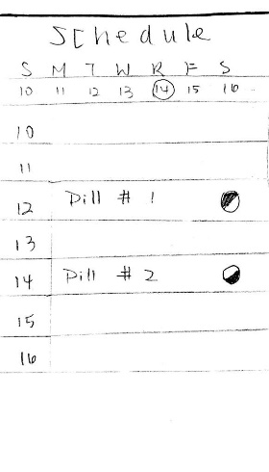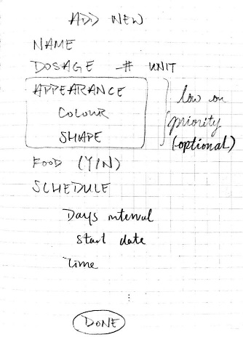

# 

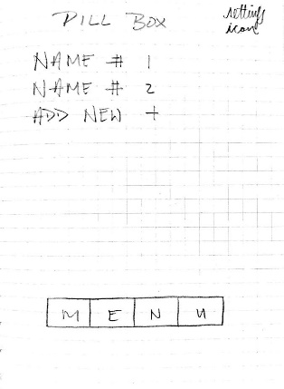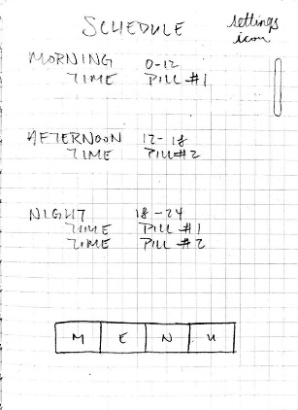

# *Figure 1: Paper prototype design for the mobile app*

The application hopes to transform, store, and display medication information and schedule on the phone, and notify user at the time medication should be taken. We hope to make the interface as simple as possible, while still contain essential information: medication name, dosage, days interval, if it is to be taken with food, and start date. The notification is the most important part of this application. It will notify the user of the medication name and dosage at the correct time. It will also record if it was taken; if no response was provided by the user, he or she will receive another notification. A report of medication adherence will later be available, which the user will be able to share with whomever he or she wishes.

The mobile application design is user-centered, and the application has gone through standard Human-Computer Interaction (HCI) design process, including low-fidelity paper prototyping and prototype testing procedures. (Figure 1)

Since the application is aimed to be of use for people of different ages and technological proficiency, we hope to create an application with a clean and easy-to-use interface. We hope to limit user error by specifying input type. We also hope to avoid implement overly complicated functions, which a normal, daily user will find no use for.

# **V. Implementation**

The application is written in Java, intended to be used on an Android device. Data is stored in an SQLite database locally. There are three activities (screens): Schedule, Pill Box, and Add New Pill. The notification function is currently not implemented due to time constraints.

Depicted in Fig. 2 (Left), the Schedule activity is separated into four sections of the day; the section of the current time will be expanded upon loading the Schedule screen. Medications will be assigned to sections according to the time they are supposed to be taken; for example, Pill A is to be taken at 9:00, so it will be assigned to the morning section in the schedule.

The Schedule activity utilizes the Expandable List View to emulate a day-view calendar, because it looks to us the simplest and cleanest interface. In the OnCreate method, the system queries the database for a list of PillTime, which the elements are then assigned to its appropriate time section. Pill Time is a class that contains the time (hour and minute) and a list of pills that needs to be taken at the time. In each time section (morning, afternoon, evening, and night), the information of each element in the list of PillTime is displayed.

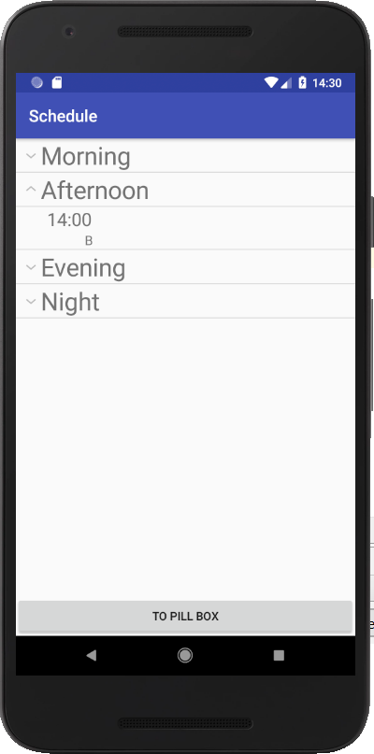 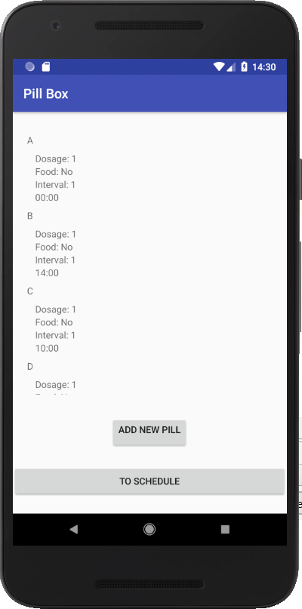

*Figure 2. (Left) Picture of Schedule screen. (Right) Picture of Pill Box screen*

Depicted in Fig. 2 (Right), the Pill Box activity displays a list of medication data entered by the user. Each entry will display the medication name, dosage, days interval, and time to be taken. Delete and edit function for medications are in development. On the bottom of the Pill Box Screen, user can click on "add new pill" to input a new medication entry.

The Pill Box activity queries the database for the full list of pills; it uses Layout Inflater to manipulate the interface. Since the number of pills is unknown until it is queried, we need a way to add a dynamic number of pills. A loop goes through the list of pills returned by the database, and the Layout Inflater manipulates an xml layout file by filling in the information of the pill. The resulting layout is added to the current activity as a UI element.

Depicted in Fig. 3, the Add New Pill activity allows user to input medication information. User can clear to restart, cancel, or save the information. Data is saved locally through SQLite database.

Our design choices, as mentioned in section IV, is to limit user errors by specifying input type. Therefore, there exists only one text field; other fields have predefined values. User must enter all the essential information before the application lets you save the data, or else errors will be displayed at the bottom of the screen, as depicted in Fig. 4.

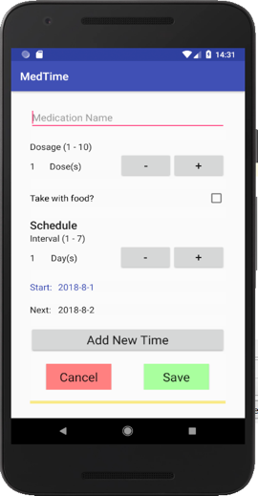

*Figure 3. Picture of Add New Pill screen*

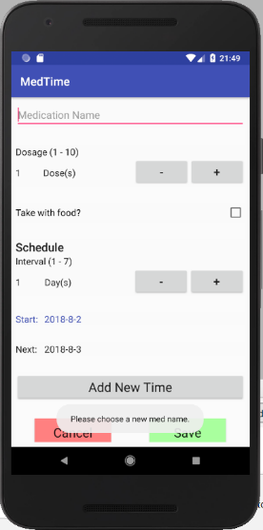 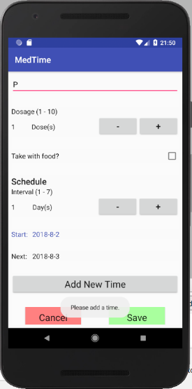

*Figure 4. Pictures of errors in Add New Pill*

Two of the biggest problems we encountered is deciding what libraries to use to achieve our goal and how to implement them in our application. As our group has only just learned Android programming for less than a month, we do not have much knowledge about it. Researching online about what libraries to use to solve our problems is difficult, because we do not know what libraries exist. However, once we have decided on using SQLite and Layout Inflater, the implementation of those libraries make more sense as we read through the Android Developers pages.

# **VI. Discussion**

Reminder-based apps are useful in many demographics. One specific demographic that can be targeted is college age students and young adolescents. At a time where apps control people’s lives, reminders for taking medication can be vital — this parallels the use of calendars and scheduling assistants. This also proves true for antidepressant drug schedules, where reminder apps were proven beneficial for medication adherence. This also proved true for adolescents who began use of an assistive app to schedule medication reminders. From a sample of 23 young adults and adolescents, more than half of participants took the medication scheduled at the time of notification, while it was also reported as a useful tool for medication reminders [2].

Similarly, in older populations, medication adherence can become a bigger issue due to several reasons. This demographic has a general tendency to require more medication, while remembering to take them becomes an increasing challenge with age. Inaccurate medication adherence can cause chronic problems to become worse, increasing costs for that individual [3]. The use of an app can remind those individuals to take certain medication, including complex information such as dosage and any precautions, which can promote a more consistent medication adherence schedule.

# **VII. Conclusion and Future Work**

Our goal of this research was to solve the problem forgetting to take certain medication by creating a medical adherence application. We aimed our project to two target groups. Group one college age students and young adolescents and group two, the elderly. We targeted these two groups because of they are the most susceptible to forgetting to take a pill. We aim to fix the problem of these two age groups.

The final application did not meet every single requirement we were given but we believe we incorporated enough to our product that it would be useable right now. We allow our users to add new medications that the may be subscribed by doctors, while also change current dosage or times if a doctor suggest a different amount of a certain medication. We needed to put our user first and give them the use of features that were not only intuitive but useful and not just implemented because it showed of our technical skills.

***For the future:*** As we have a good starting point for our application, we see that there can be many improvements to the application that we currently have. In the future, we want our application to take the stress out having to remember whether one has taken one’s pill or not we can solve this problem. Utilizing a notifications feature, the user is forced to record that he or she has taken the pill, and then the application will record that information for medical doctors to analyze the patients’ medication history. To address the problem that the elderly have with technology, we want to implement multi-user functionality. This requires a login/account to make specific data and personal information able to be transferable to different devices, as well as making the specific data for the user private. Having multiple users would mean that a son, daughter, or caregiver can check if the main user took his or her pill. This would cause redundancy, making sure that they have taken their necessary medications. Also, this will allow users to access information from another device in case their primary device is damaged, lost, or stolen.

As for handling the information, we would need to improve from local storage, which we currently are doing, because we only have one possible user. We would need to explore the options of finding a system that would be safe enough to handle sensitive patient information but also allow information to be shared to other users with the proper permissions. We believe the right direction to go would be implementing “the cloud” into our memory functionality.

# **Acknowledgement**

This research project is honorably sponsored by Wentworth 2017-18 Presidential EPIC Mini Grants.

# **References**

[1] Sabaté E, editor., ed. Adherence to Long-Term Therapies: Evidence for Action. Geneva, Switzerland: World Health Organization; 2003.

[2] Wu, Y. P., Linder, L. A., Kanokvimankul, P., Fowler, B., Parsons, B. G., Macpherson, C. F., & Johnson, R. H. (2018, January 01). Use of a Smartphone Application for Prompting Oral Medication Adherence Among Adolescents and Young Adults With Cancer.

https://www.ncbi.nlm.nih.gov/pubmed/29251285

[3] Billingsley, L., & Carruth, A. (2015, August). Use of Technology to Promote Effective Medication Adherence. Retrieved from:

https://www.ncbi.nlm.nih.gov/pubmed/26247653

[4] Hammonds, T., Rickert, K., Goldstein, C., Gathright E., Gilmore, S., Derflinger, B., Hughes, J. W. (n.d.). Adherence to antidepressant medications: A randomized controlled trial of medication reminding in college students. Retrieved from:

https://www.ncbi.nlm.nih.gov/pubmed/25338175

[5] Santo, K., Richtering, S. S., Chalmers, J., Thiagalingam, A., Chow, C. K., & Redfern, J. (n.d.). Mobile Phone Apps to Improve Medication Adherence: A Systematic Stepwise Process to Identify High-Quality Apps. Retrieved from:

http://mhealth.jmir.org/article/citations/6742